

A2Mall

Web Scraping For Affiliate Marketing

|  |  |  |
| --- | --- | --- |
| Mohit  Prajapati  [B26] | Hemant  Jangid  [B13] | Urvashi  Khatri  [B47] |

|  |  |  |
| --- | --- | --- |
| INTRODUCTION | | |
| What is A2Mall? | | |
| A2Mall is Affiliate Marketing Website which Display Products from Amazon ( Web Scrapping ) and earn Revenue from affiliate marketing. | | |
| Affiliate Marketing is new concept in ecommerce sites which provides certain amount of percentage when we sell their product to the customer.  Many of us like student, Housewife can easily earn money from affiliate marketing and we can also continue as side income. |  | **Web Scraping for affiliates is a website in which admin will advertise products from Amazon.in by creating affiliate links. When the customer clicks the link and buy product from Amazon, the admin will generate revenue from the Amazon Affiliate Program** |
| X`How to start Affiliate marketing - Opencube Lab | | |

**Existing System**

* **According to our current search on web we didn’t find any existing system in India who offers platform to sell affiliate products**

**Need for New System**

* **Existing affiliate programs provides and share only with link but we create website which will find price automatically with the help of boat which automatically fetch and update price with particular time period.**

# Problem Definition

* **Web Scraping for Affiliates is a website in which admin will advertise products from Amazon.in by creating affiliate links. When the customer clicks the link and buys the product from Amazon, the admin will generate revenue from the Amazon Affiliate Program.**
* **Affiliate marketing is a type of performance-based marketing in which a business rewards one or more affiliates for each visitor or customer brought by the affiliate’s marketing efforts.**

# Core Components

* **Auto Bot Module**
  + This module allows our software to get the latest update on the price of the products. This bot can be scheduled as per requirement using CRON Jobs. According to the schedule, the bot continues the work as per the log. which is stored in Database.
* **Scraper Backend Module**
  + Scraper's Backend Module is tightly integrated with the Auto Bot Module, as it uses the Auto Bot components to fetch the product data, such as title, price, description and brand of the product.
* **eCommerce Frontend Module**
  + This module is exclusively made for A2Mall, which means - the Frontend module is integrated as per Auto Bot requirement. The Frontend Module packs with feature to Wishlist the product and show Featured products, using which the Affiliate can earn more revenue.

**Tools & Technology**



* **Hardware**
  + **Processor: 1.6 Ghz or Above**
  + **RAM: 1GB or Above**
  + **Storage: 8GB or Above**



* **Software**
  + **Web Server: Apache (PHP)**
  + **Frontend: HTML, CSS, JavaScript**
  + **Backend: PHP, MYSQL, cURL, CRON, macOS**
  + **Others: VsCode, Chrome**

**Diagrams**

* **System Flow Diagram**

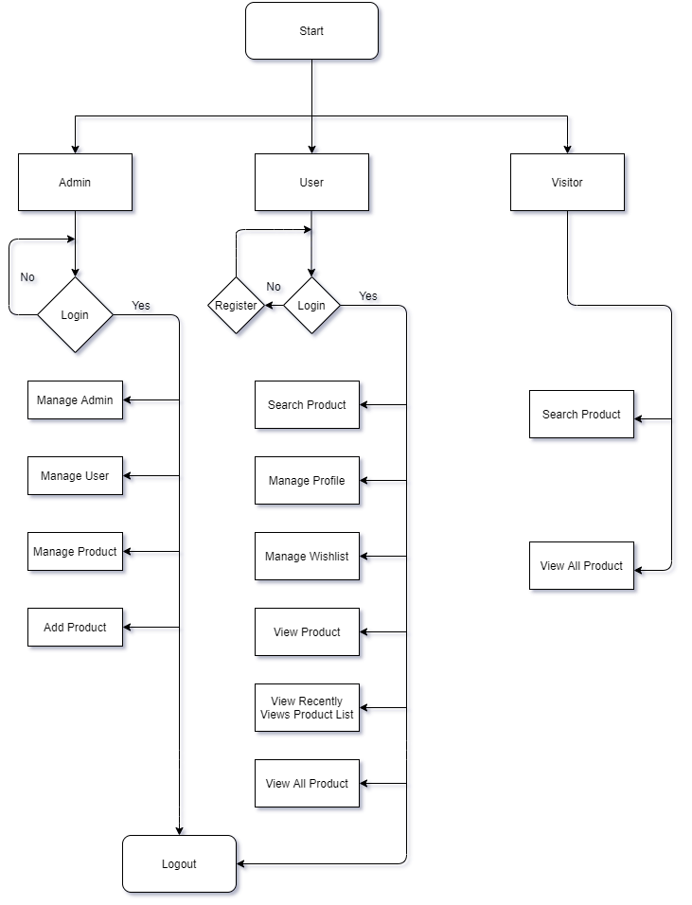

* **Use Case Diagram: Customer**

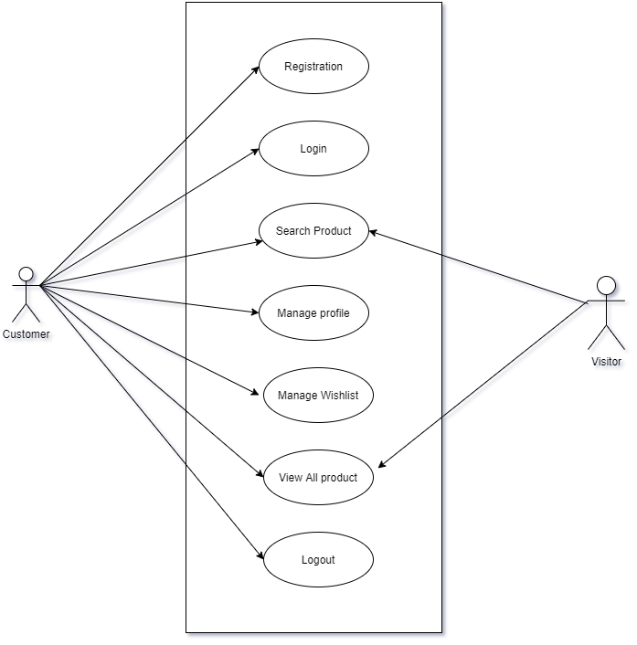

* **Use Case Diagram: Admin**

**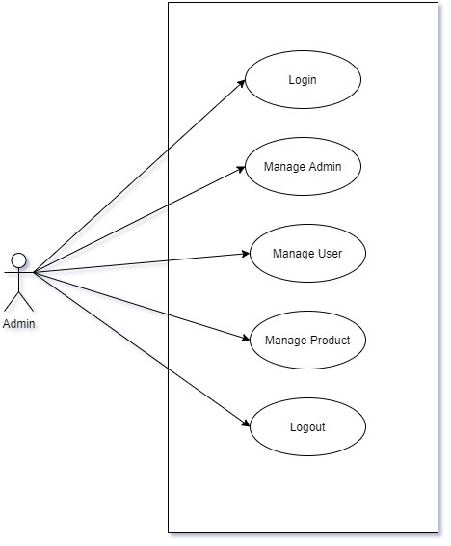**

|  |  |  |  |
| --- | --- | --- | --- |
| * **Activity Diagram**   **C:\Users\Hemi\Downloads\activity_diagram.png** Data Dictionary **“Admin Table “**    **“Product Table “**    **“Users Table “**  **“Wish list Table “**  **“Price Sync Table “**  **“Price Sync Master Table “** | | | |
|  | | | |
|  | | | |
| Admin side ScreenshotsC:\Users\Hemi\Desktop\login.png | | | |
| C:\Users\Hemi\Desktop\login_validation.png | | | |
|  | | | |
| C:\Users\Hemi\Desktop\all_admin.png | | | |
| C:\Users\Hemi\Desktop\all_user.png | | | |
|  | | | |
| C:\Users\Hemi\Desktop\all_product.png | | | |
| C:\Users\Hemi\Desktop\add_product_1.png | | | |
| C:\Users\Hemi\Desktop\add_product_2.png | | | |
| C:\Users\Hemi\Desktop\add_product_3.png | | | |
| C:\Users\Hemi\Desktop\add_product_5.png | | | |
|  | | | |
| Bibliography  1. [**https://stackoverflow.com/**](https://stackoverflow.com/) 2. [**https://laravel.com/**](https://laravel.com/) 3. [**https://www.djangoproject.com/**](https://www.djangoproject.com/) | | | |
|  | |  |  |
|  | |  |  |
|  | Add an additional item you wish to highlight in this area. Make sure that you include contact information, event details, or other important topics that your audience will need to know! | | |